Adding a page to the menu

Creating a page doesn’t automatically add it to the menu. Once the page is exactly as you would like it to appear online you can add it to the menu.

Under “Appearance” in the left menu (below Dashboard, Posts, Media, Links, Pages, Comments etc.) click on “Menus” from the fly-out menu:
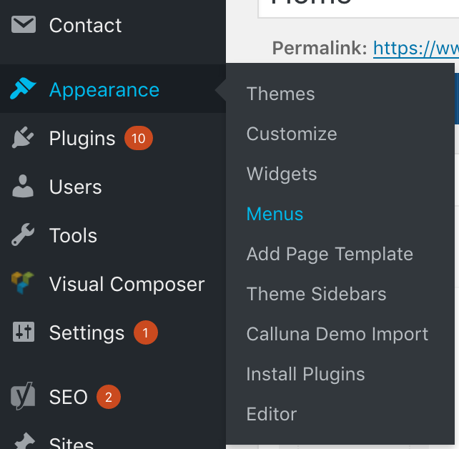

This will load a page showing you all of the pages created (under the “Pages” section to the left) as well as a list of all pages in the current menu:
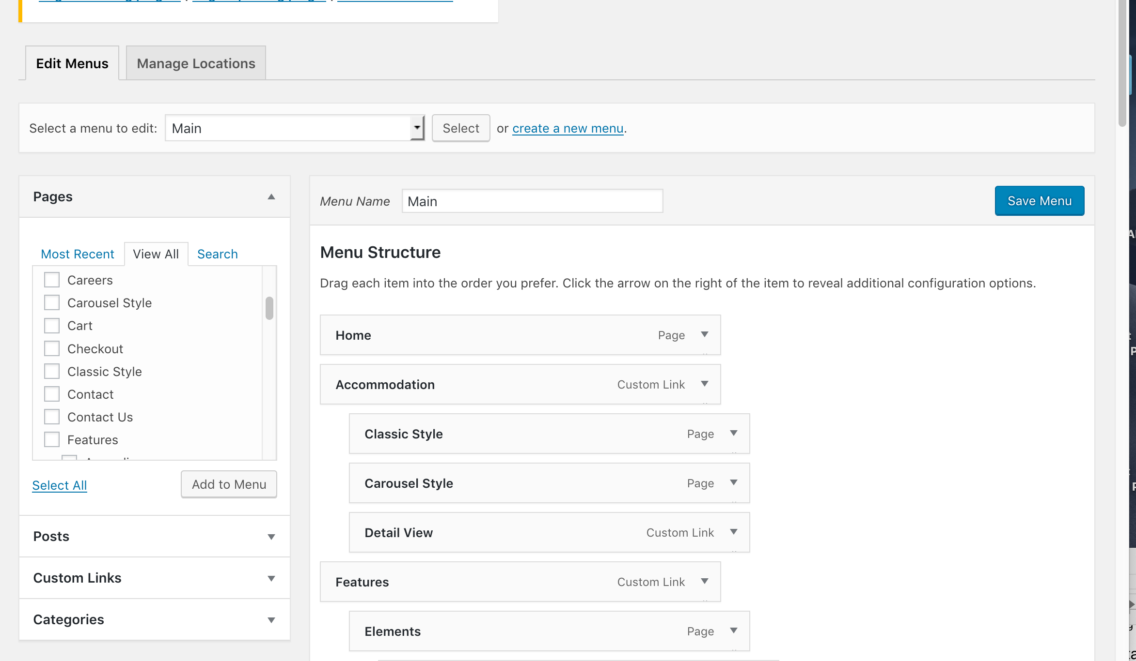

This allows you to add new pages to the menu, or to rearrange the order of pages (it's a drag and drop format) in the menu.

To add a page, find the page you want to ad under the "Pages" menu to the left. Check the box beside the page you want to add ("Careers" in this example) and click "Add to Menu".
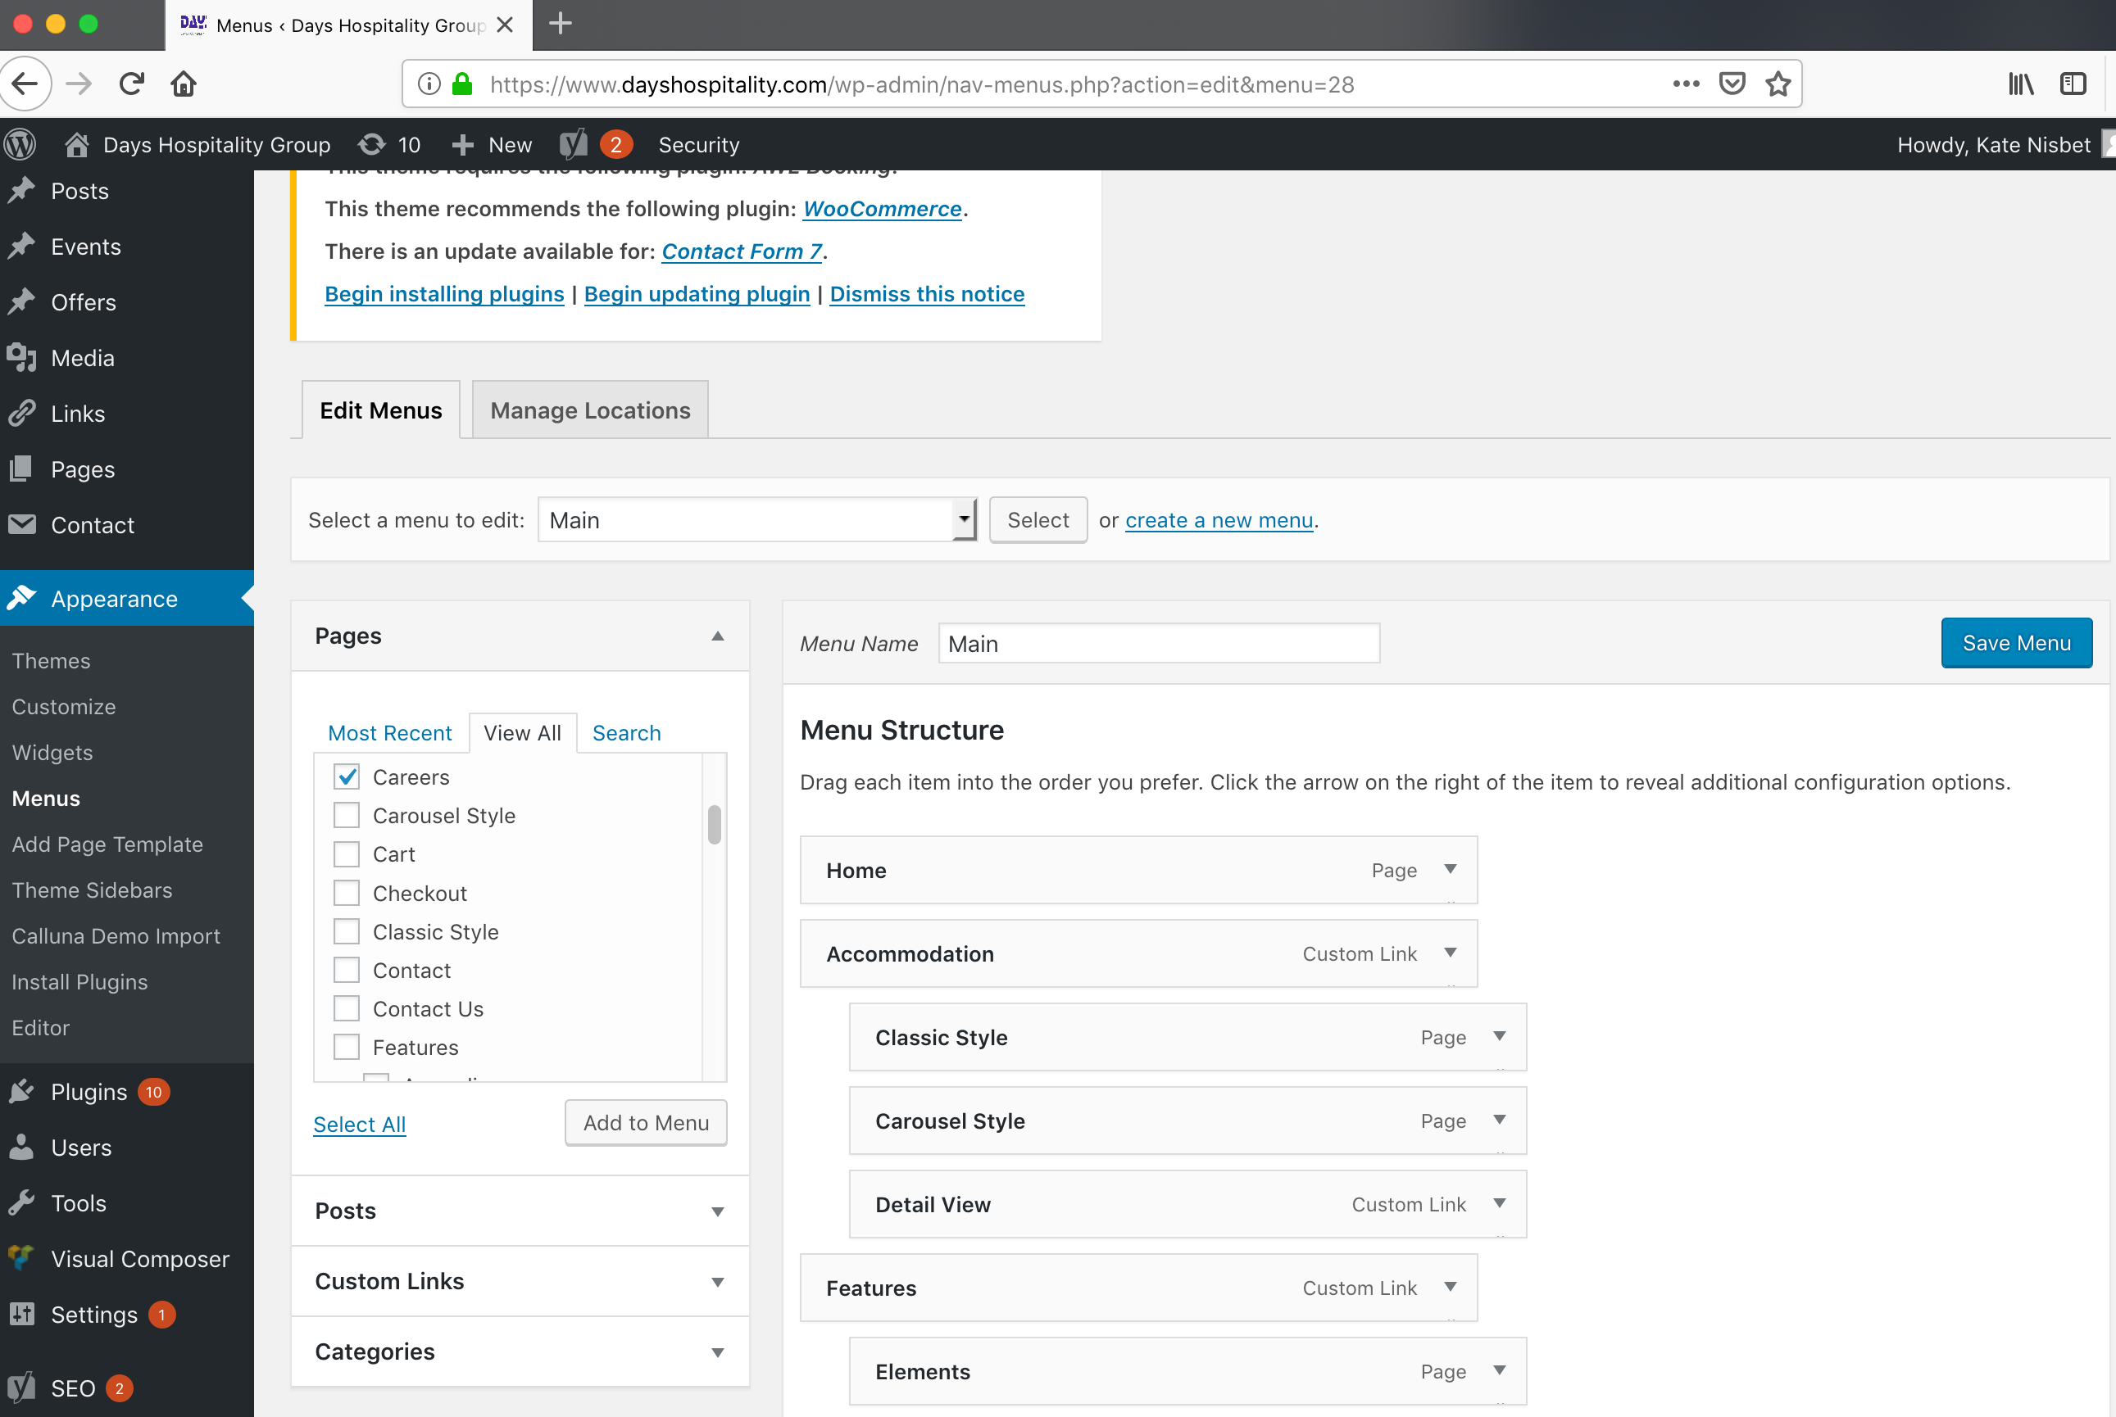

You will then see this new page at the bottom of the menu, scroll down to find it. You can drag and drop it under the correct section (under "Contacts" in this example.
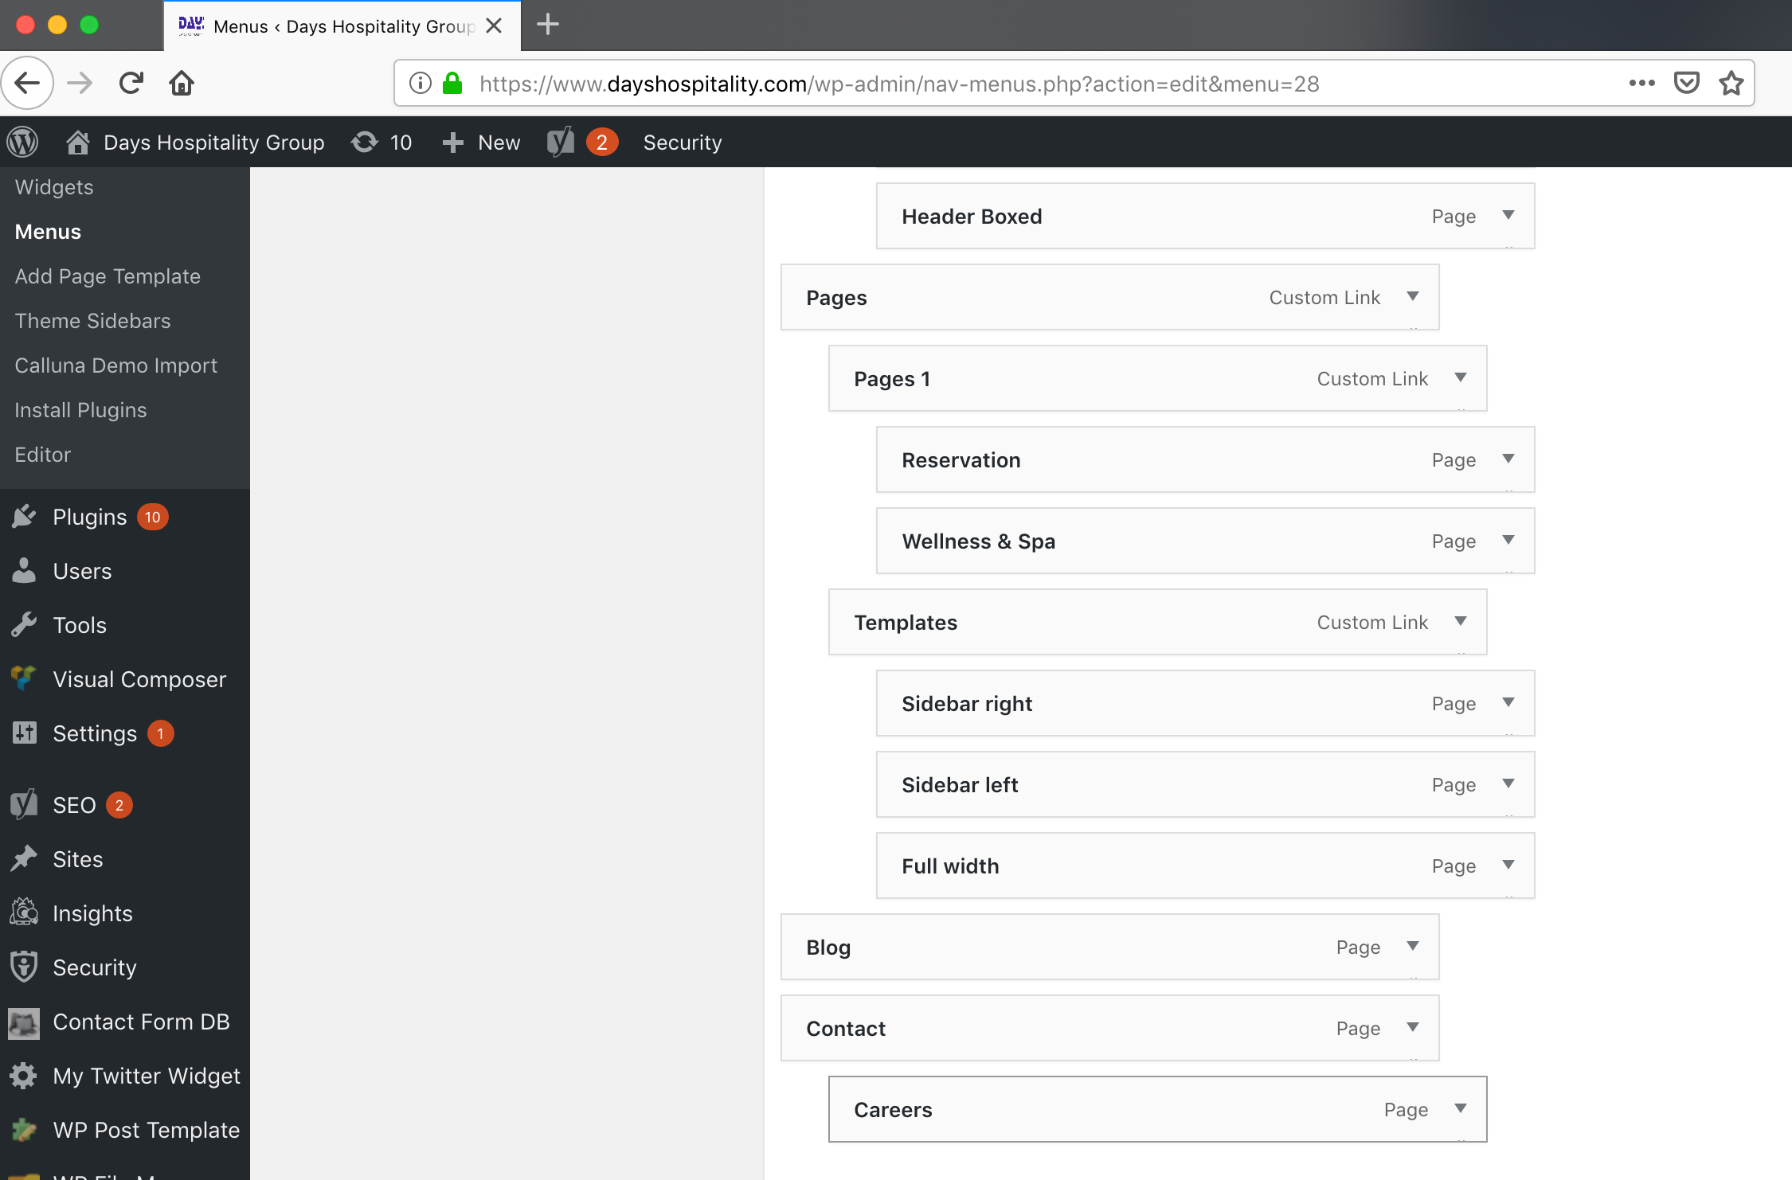

Once your menu is correct, click "Save Menu".

