Uploading and linking to PDFs

Uploading

You can upload PDFs the same way you would upload an image. Everything (images and PDFs) will appear in the Media Library once uploaded.

Linking

When you select a PDF to place into the body of a page, you will follow the same steps as you did to insert an image into the body of a page. (Once you have your cursor in the body of the page you are editing, click "Add Media.)

Select the PDF you would like to insert into your page. We will use “RLVCA-Creative-Brief.pdf” as a PDF example (already uploaded). Fill in the text field beside "Title" in the "Attachment details" (in this example, “View RLVCA Creative Brief (PDF)”). This will be the text that appears in your page, when you're linking to that PDF. Make sure "Media File" is selected from the "Link To" dropdown menu. Then click "Insert into page".

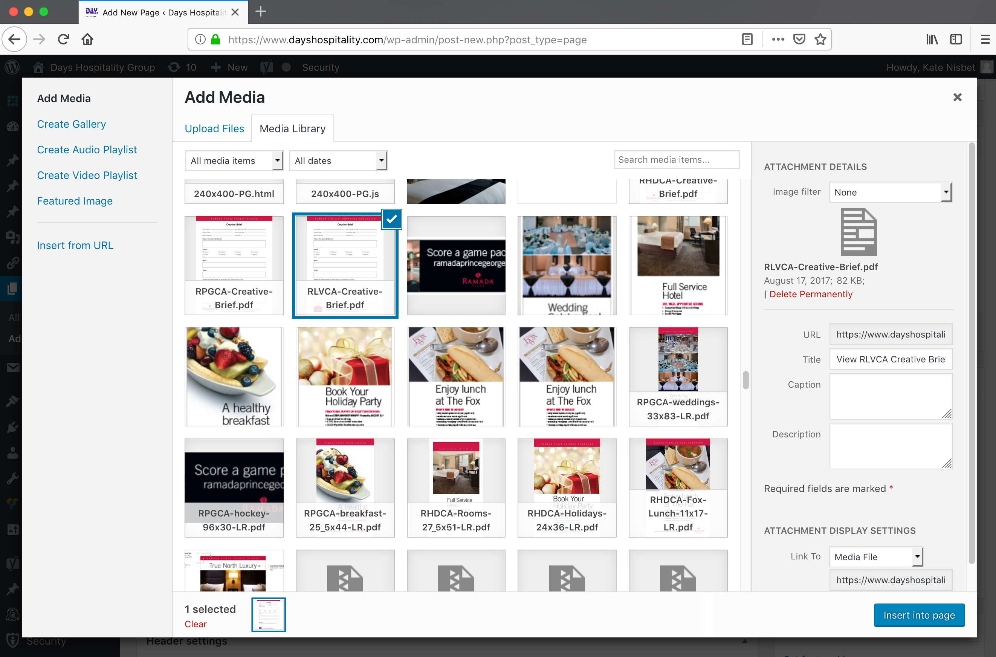

Once you click “Insert into Post” it will appear as you see below:

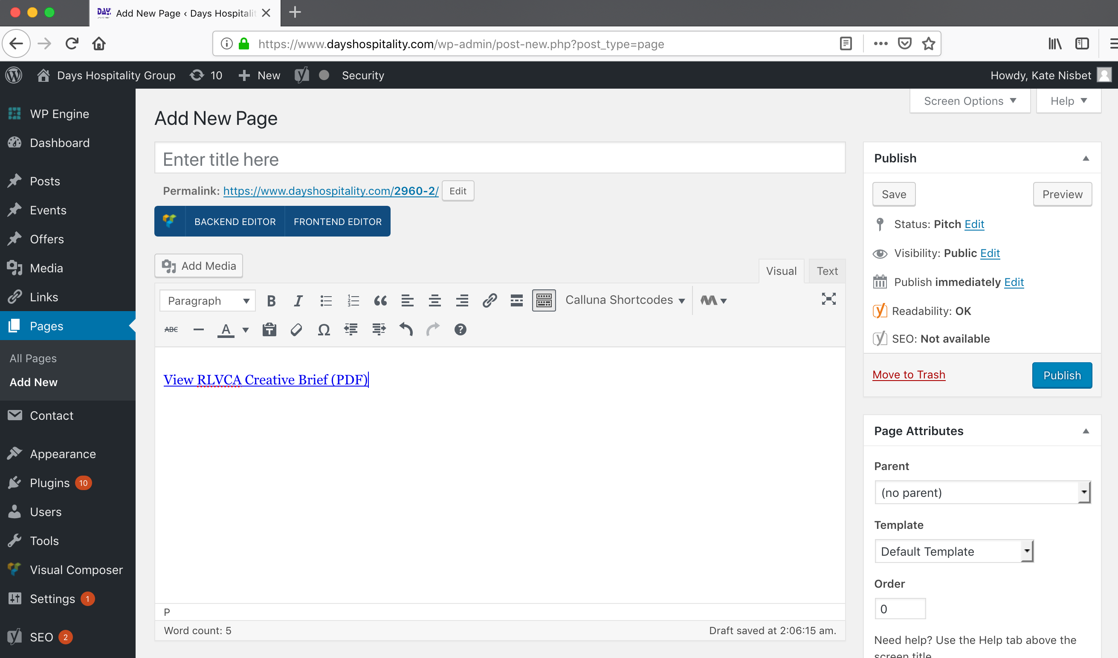
When you save the page this text link will open, or download the PDF, depending on your browser preferences.

Add hyperlink to an image

To insert a hyperlink for an image, click the image in the body of the page that you would like to link, and then click the “Insert/edit link” button in the tool bar which looks like 3 links of chain as you see here:


This will open the Insert/edit link window as you see here. Click the gear icon to open the options for the link.


This is where you can fill in the link information.

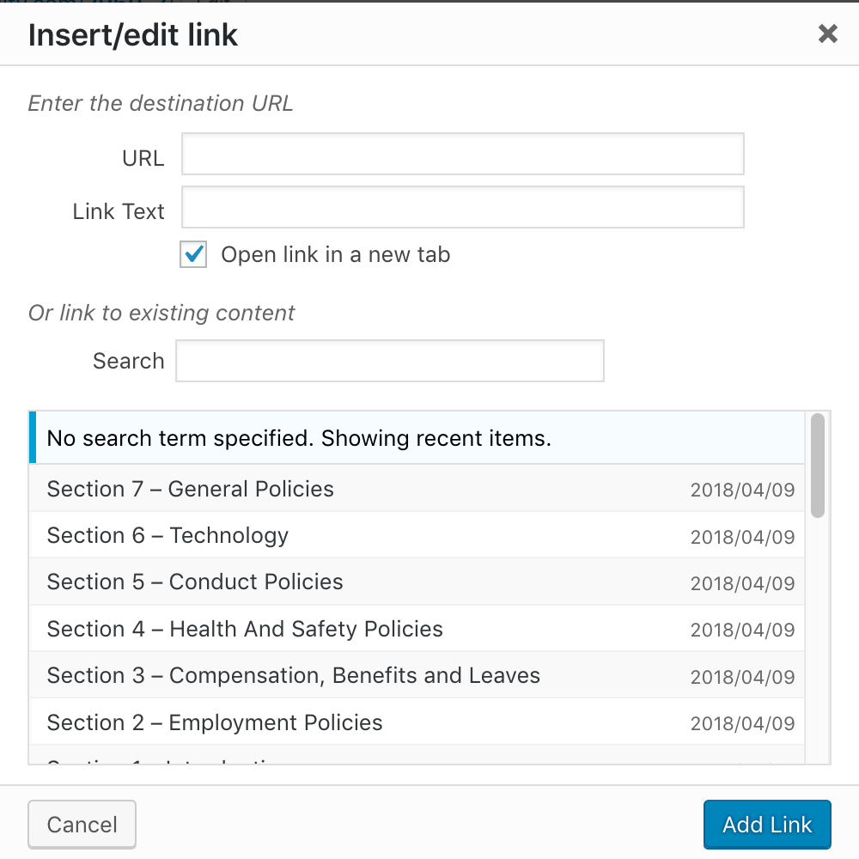

You can have the image link to a URL or to a page in the hotel's website.

If you want to link to an external web page, type the URL in the “URL” field. It’s advisable to open a new browser window for external pages, so that the hotel's website stays open in the background. To do this check the box beside “Open link in a new tab. Click “Add link” and your image is now linked to that external web page.

If you're linking to a page in the hotel's website, it’s advisable to have "Open link in a new tab" unchecked so that the link reloads the new hotel page in the same window. You will see the list of pages that currently exist within the hotel's website. You can choose any of them and then click "Add Link".

Add hyperlink to text

Text links are handled exactly the same way. Rather than clicking the image, hi-lite the text you want to link using your cursor; click the Insert/edit link button and follow the same procedure.
Add Email link

Inserting an email link is basically the same procedure.

Hi-lite the text you want to open a mail message when clicked. It needn’t be the email address — in fact, it’s advisable to make it something other than the email address such as “email us”, which helps prevent spam bots from scraping your email address and adding it to spam databases.

When the text is hi-lited, click the Insert/edit link button and, in the URL field delete enter mailto: followed by the email address with no spaces like so:
mailto:kate@farandwide.marketing

Then click “Add link”.

