Uploading an image

In the left toolbar you will find “Media” (below "Posts", "Events", and "Offers"). Clicking on “Library” will bring you to a page that lists all images/graphics/PDF’s previously uploaded.

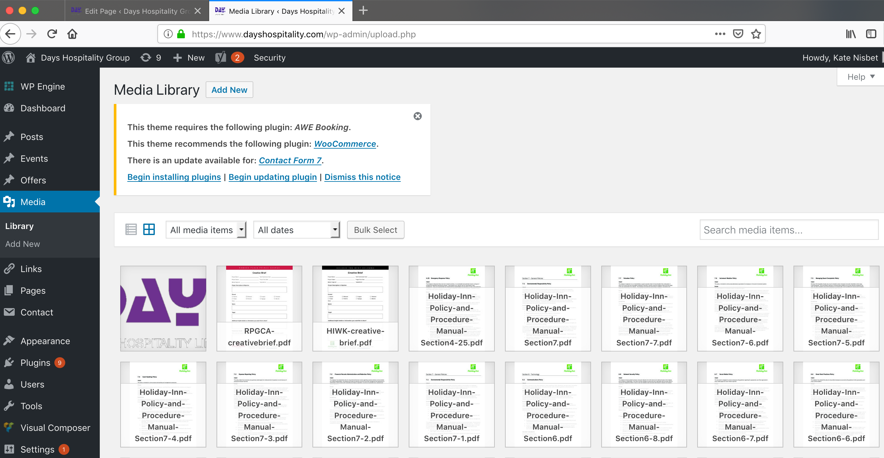

Clicking on any of the listed items will allow you to edit the item’s Title, caption and description.

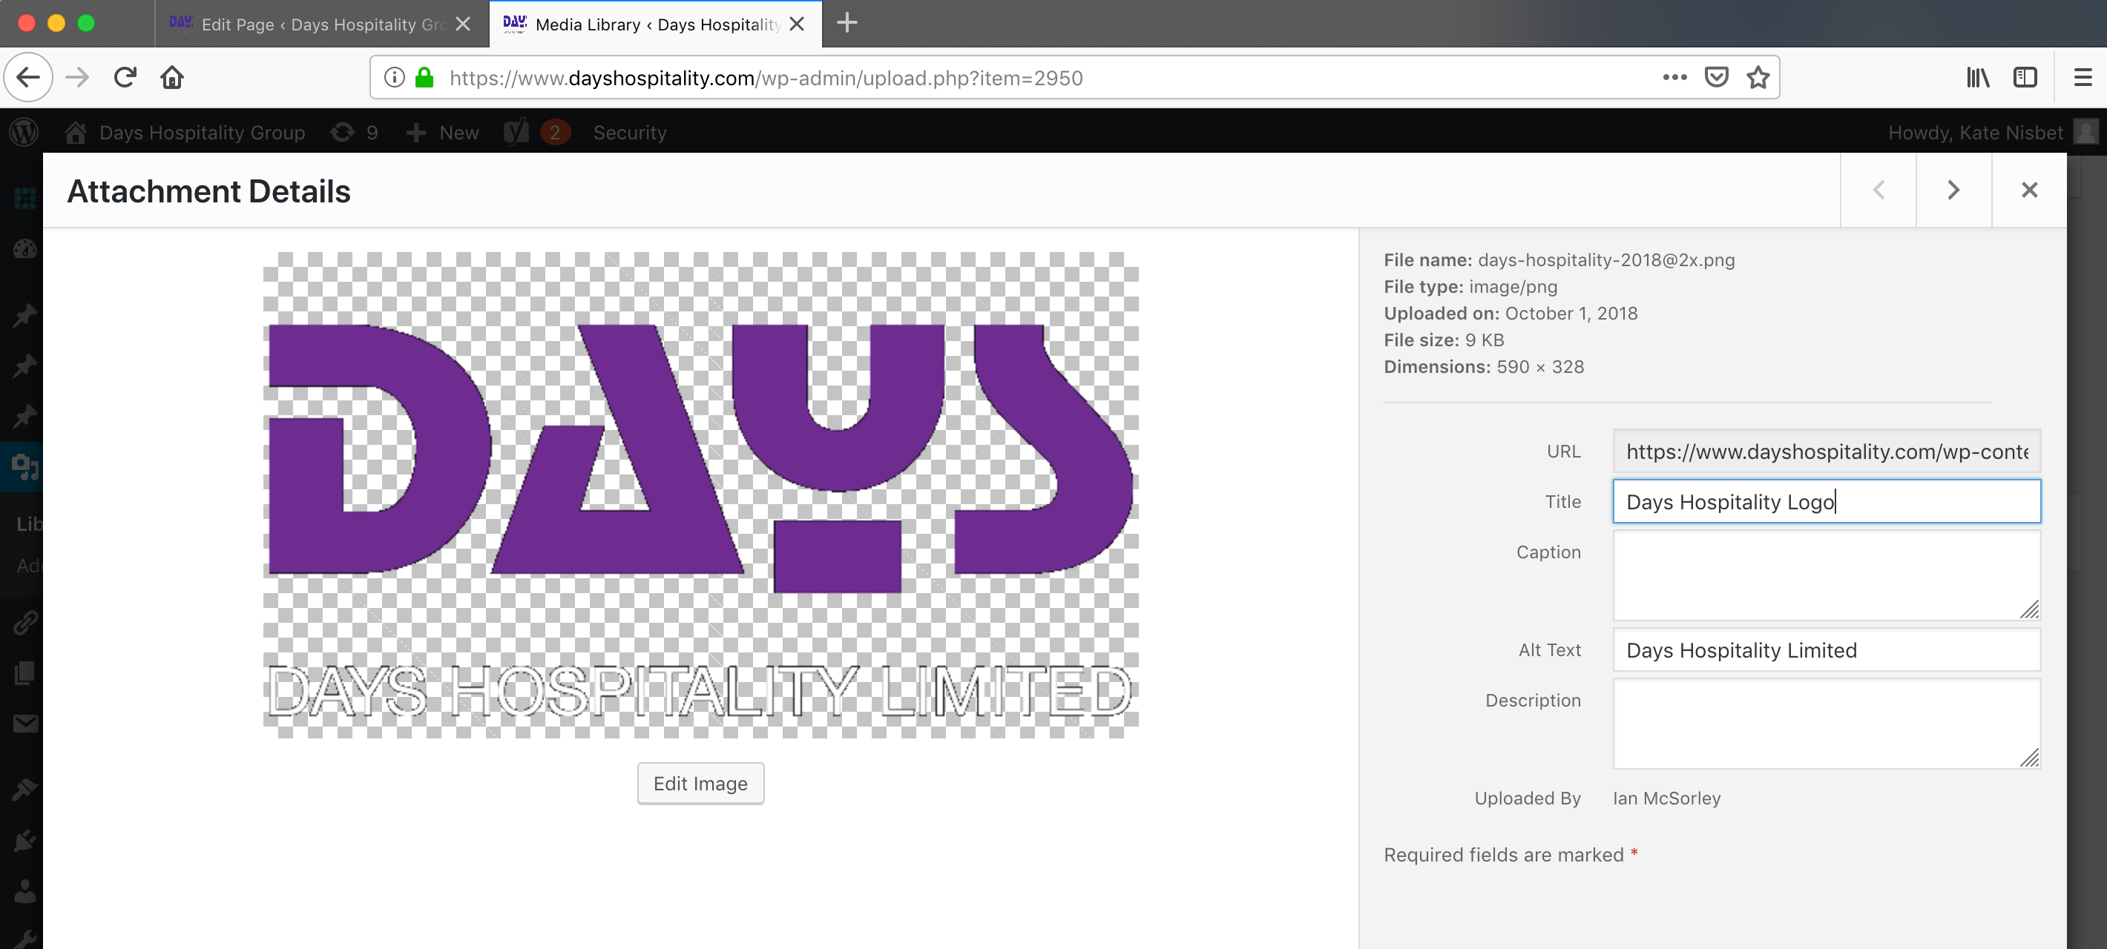

Clicking on “Add New” will allow you to upload a new image to the Library without inserting it into a page. You can either drag and drop files or click “Select Files” which will open a new window as you see below:

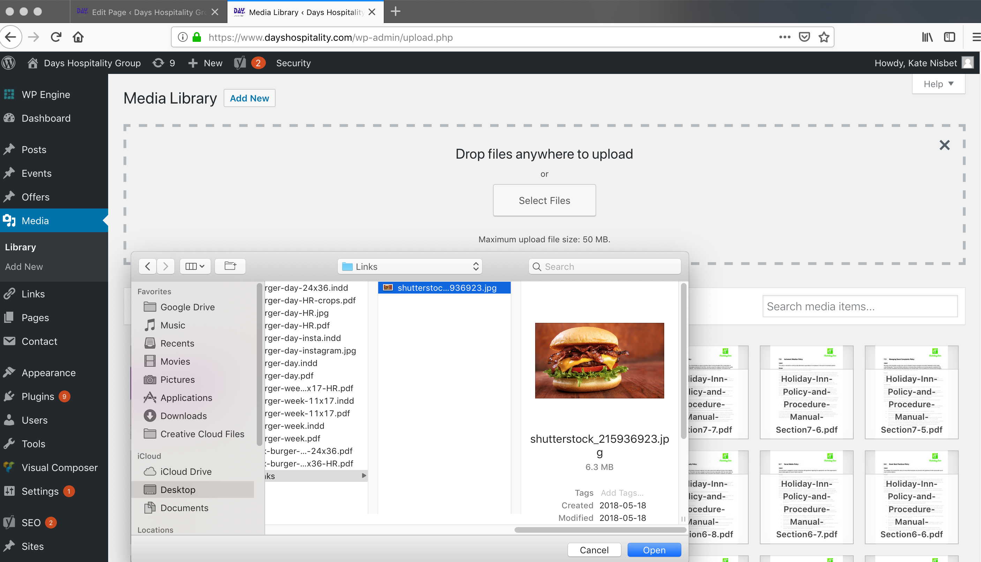
Navigate to the file you want to upload. Click it and click the “Open” button which will upload your image, then allow you to edit the Title, Caption and description of the image.

