There are 2 primary groups of content in WordPress sites: Posts and Pages. Both are located in the left toolbar.

Posts

Posts are effectively a blog or “News” section. Currently, we are not using posts for any of the hotel websites. They are edited in the same way that Pages are managed and edited (instructions to follow).

If and when you want to start using the Posts feature of WordPress we will detail procedures for managing those.

Pages

Click 'Pages' (6th item from the top in the left toolbar; below ‘Posts’, 'Events', 'Offers', ‘Media’, and ‘Links’) which will display an index of the pages that currently exist for your hotel's site.
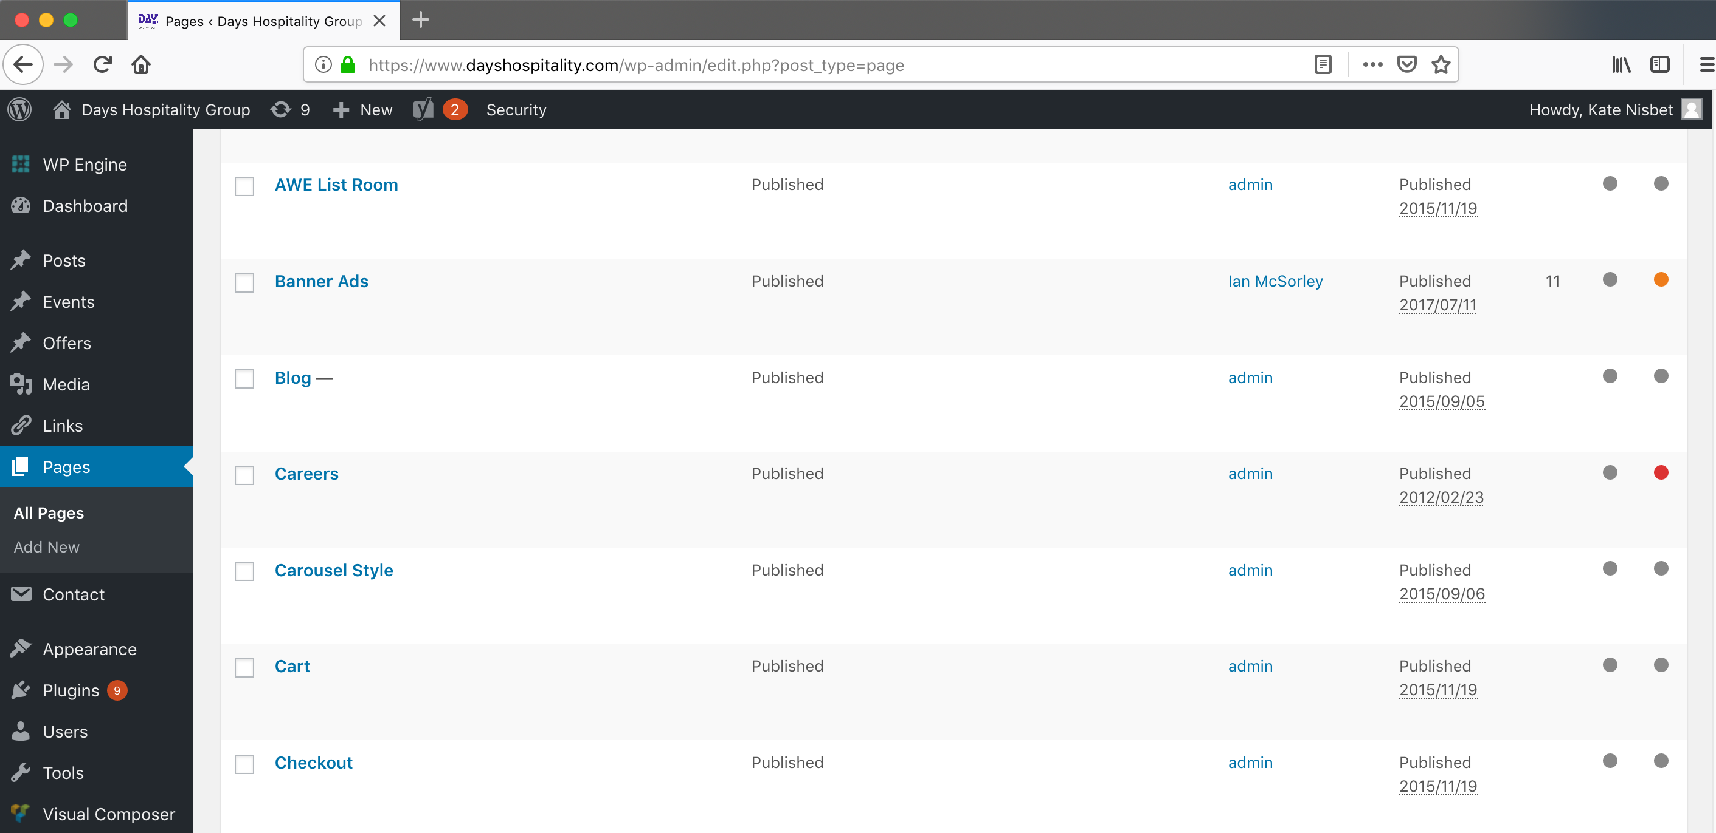

Create a New Page

To create a new page for the site, click “Add New” which appears below the “Pages” section. You’ll be taken to “Add New Page” as you see here:

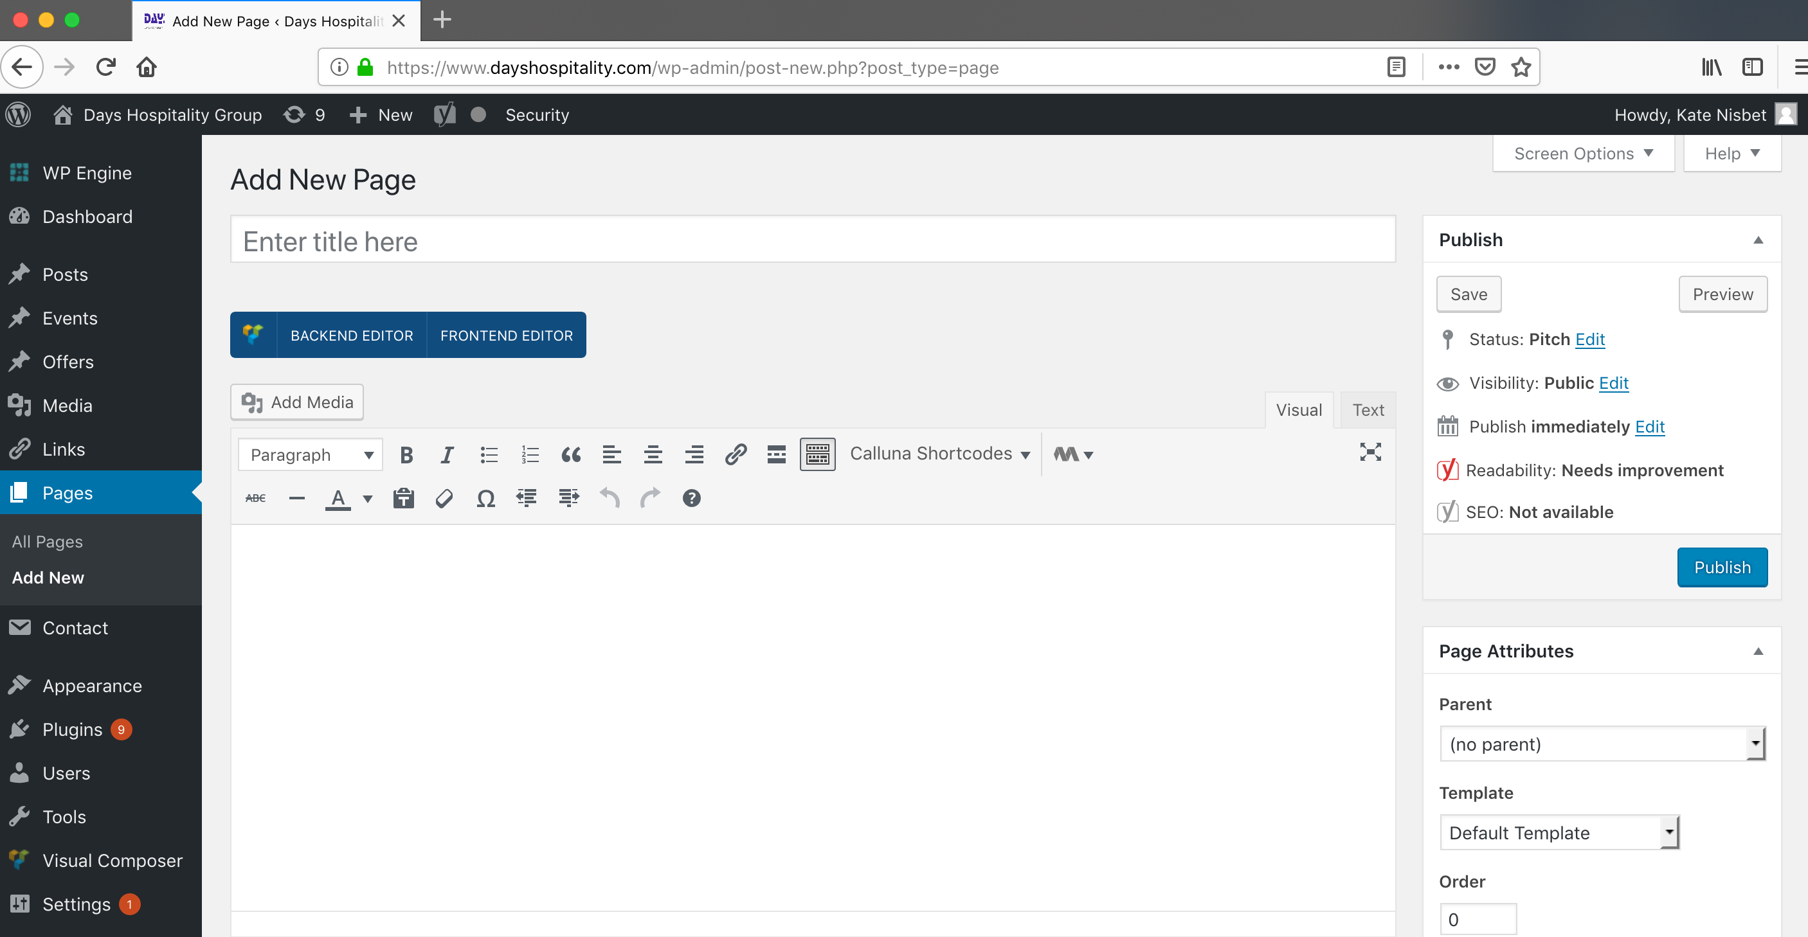
Page Title: The text field directly below “Add New Page” is where you will fill in the page title, which is what will appear in the navigation as well as the heading text on live pages.

There are several options for creating content. Classic mode, Backend editor, and Frontend editor. We prefer that you use Classic mode to keep things simple for beginners using Wordpress.

Content: When entering the content, it’s very important not to paste text directly from Microsoft Word. MS Word files bring along a lot of code markup that will conflict with your web pages.

Instead, you should copy the text of your Word file and paste it using the “Paste as text” tool (highlighted in the toolbar, shown below):

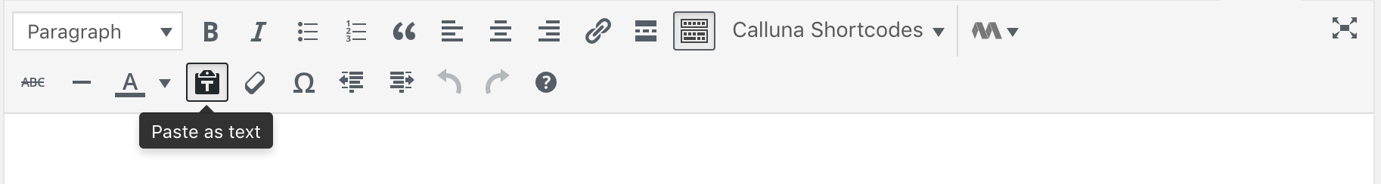

This will strip out the Word formatting tags.

You can also type directly into the Page Content fields of WordPress, but this means you don’t have a back-up file on your local drive. This is not advisable, since a loss of your internet or network connection could result in lost content if you don’t save frequently. Best practice is to write content and save it on our local drive, then follow the copy/paste procedure outlined above.

Once you’ve inserted your text, you can format it using the tool bar (pictured above) the same way you would use the toolbar in MS Word (bold, italics, bullets etc.)

When your page content is completed for this page, click the “Draft” option from the dropdown menu beside "Status:". Then click "OK" and "Save draft".
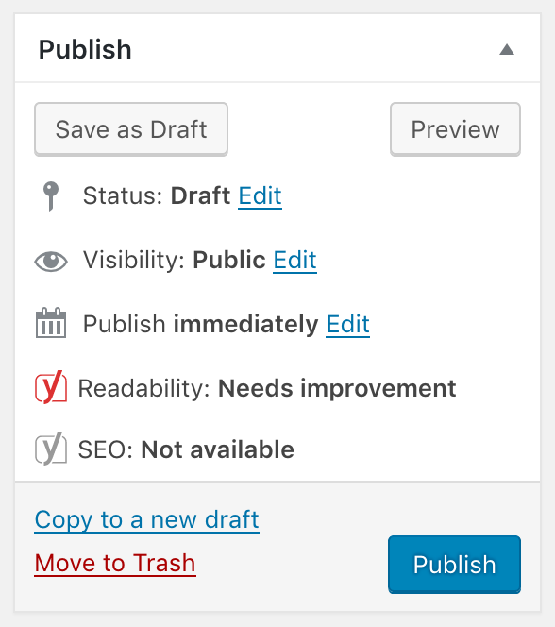

Your page is now saved, but not published (it won’t yet appear on-line) which means you can test it and have others approve content before publishing.

Preview Page before publishing

You can preview your page before publishing. Under the main menu, click "View Page".
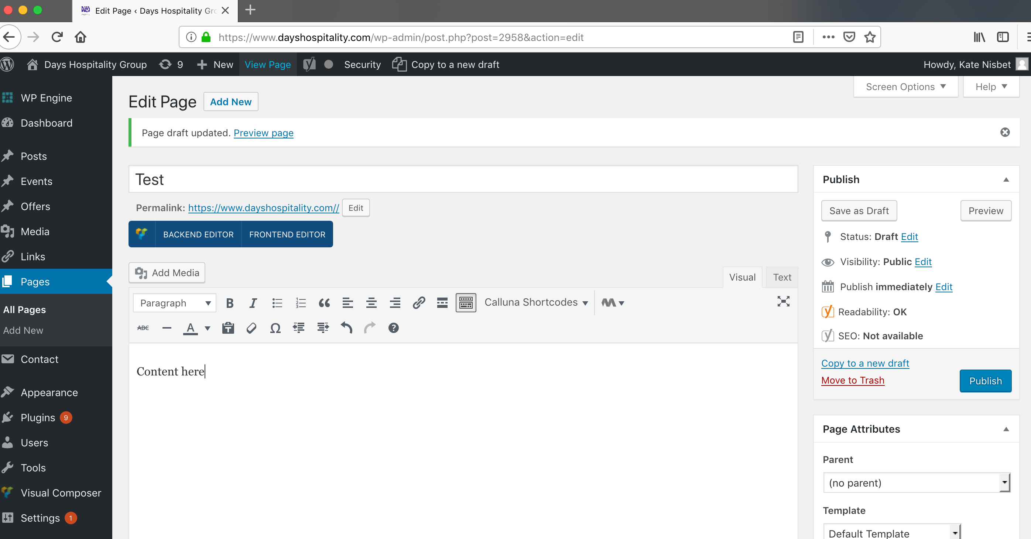
You will see that you haven't added a header image yet, which we will do in the another tutorial.

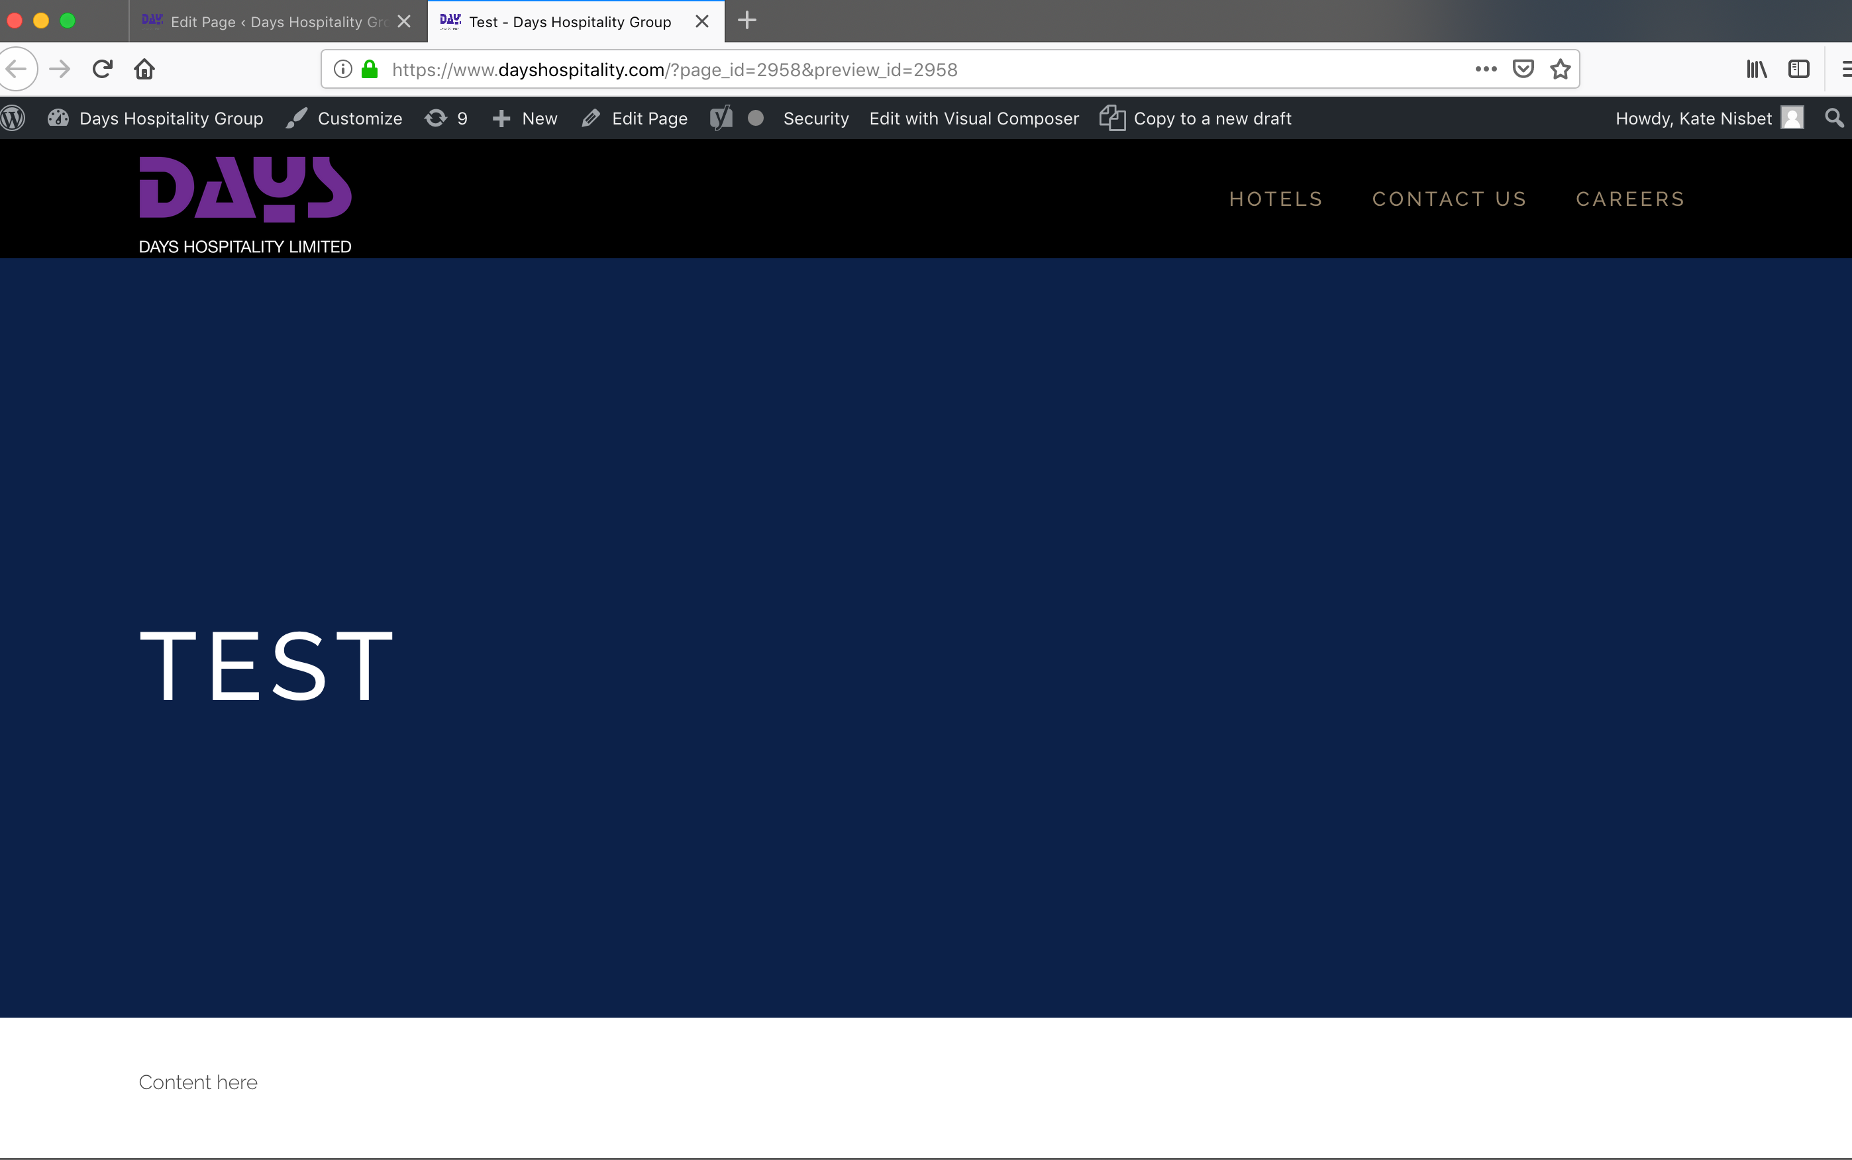

Publishing a Page

To publish the page, click the blue “Publish” button in the Publish toolbar on the right. If you’ve already navigated away from this saved page (to the page index for example) click “Edit” below the page you would like to publish. This will return you to that page, allowing you to edit or publish it.

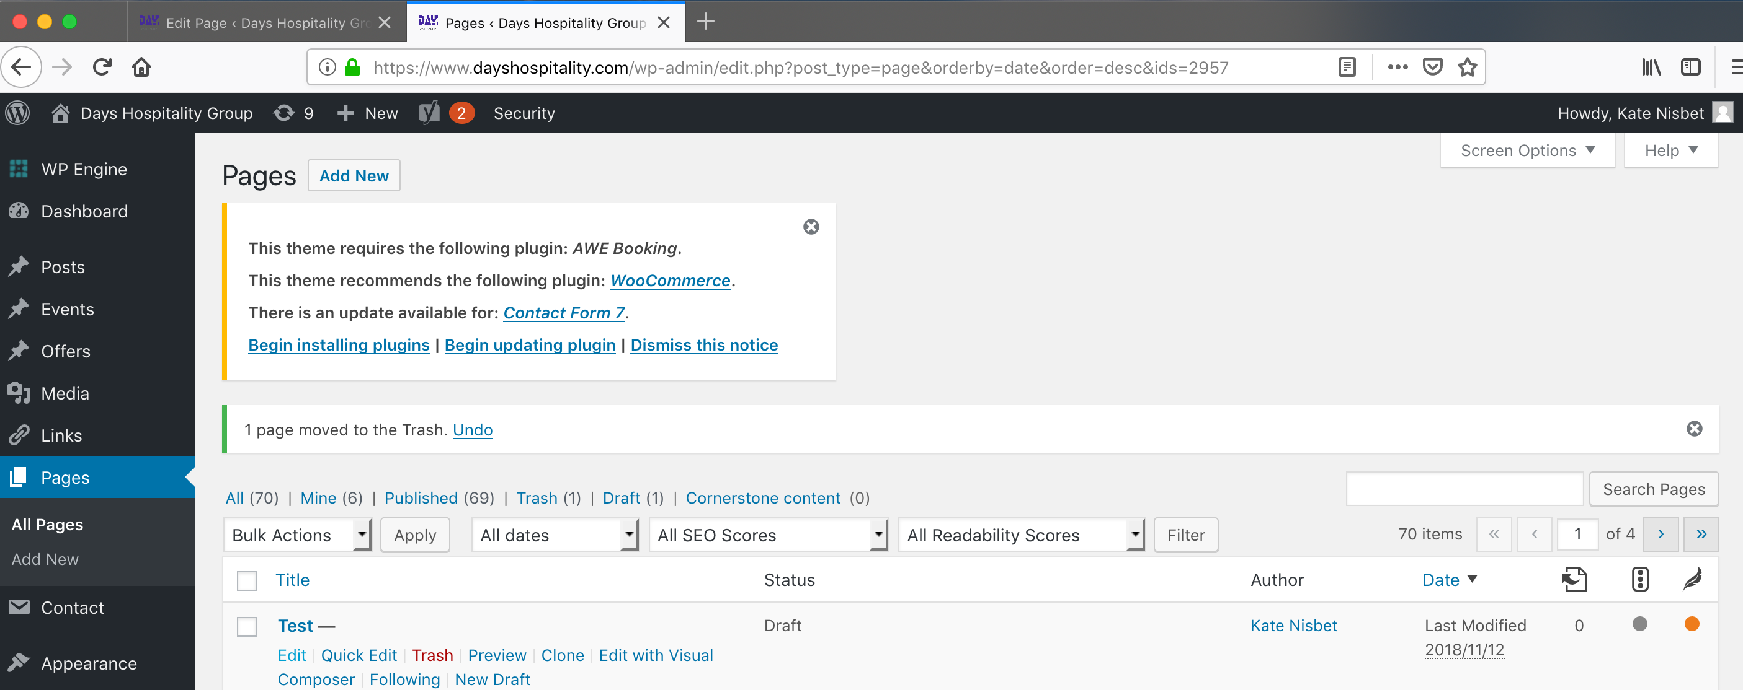

To make this page live, click the blue “Publish” button. Had you clicked the publish button when you first entered the page content, you would have saved the page and published it in one step.

